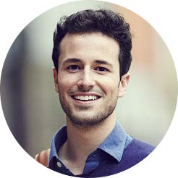

**education**

2015 – 2016 TELERIK ACADEMY SOFIA

Degree in Computer Science

2013 – 2015 TECHNICAL UNIVERSITY OF VARNA

Master’s degree, Computer Science

2009 – 2013 TECHNICAL UNIVERSITY OF VARNA

Bachelor of Science (BS), Electrical and Electronics Engineering

2004 – 2009 Language school in Sofia

English Language, French Language

IT Specialist

Born on 12.08.1989 in

Sofia, Bulgaria

**ivelin**

**stoyanov**

**work experience**

I am a young software

developer passionate

about working with

enthusiastic teams on

challenging new

projects from the

technology world.

**About me**

01.2016 – present EPAM SYSTEMS

Software Engineer

2013 – 2015 MUSALA SOFT

Software engineer

2012 – 2013 MUSALA SOFT

Junior software developer

2011 – 2012 VM WARE

Software Intern

**volunteer work**

**Personal**

**interests**

2014 – 2015 PROJECTS ABROAD

System services provider

2013 – 2015 BALKAN KIDS FOUNDATION

Event organisation volunteer

2012 – 2013 PEOPLE TO PEOPLE INTERNATIONAL

Sofia Chapter President

IT Technology

WEB Services

Developing software

Open source software

Outdoor sports

Fitness

Technology

Innovations

**Contact**

Mladost Bl.322

1423 Sofia

i.stoyanov@cv.com

00359 123 456 789

Android, Java, Linux, C++, C#,

OOP, C, Programming, Matlab,

Javascript, Flash

BULGARIAN Native fluency

ENGLISH Excellent proficiency

GERMAN Working proficiency

FRENCH Basic proficiency

**SKILLS**

**LANGUAGES**